Teacher Resource 10.1
Presentation Notes: How Insurance Provides Financial Protection
Before you show this presentation, use the text accompanying each slide to develop presentation notes. Writing the notes yourself enables you to approach the subject matter in a way that is comfortable to you and engaging for your students. Make this presentation as interactive as possible by stopping frequently to ask questions and encourage class discussion.
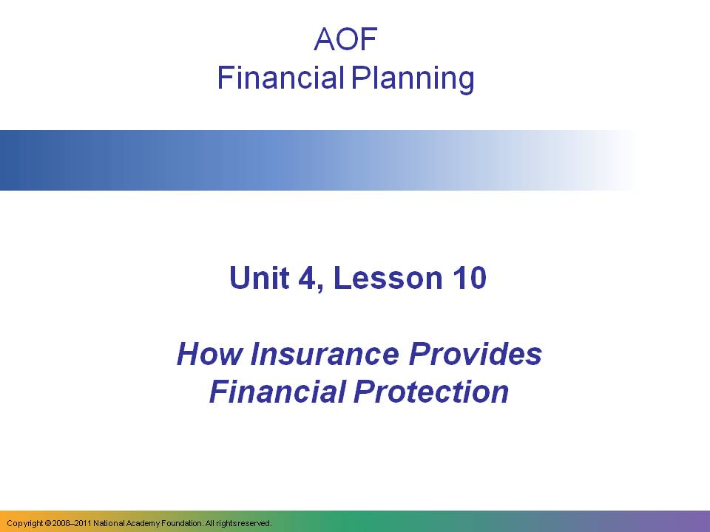  This presentation on insurance covers the following topics:  - Why insurance is an important component of a financial plan  - How insurance companies help people to spread financial risk  - How insurers create actuarial tables to allow them to estimate likelihood of risks and their cost  - How to purchase insurance coverage | Presentation notes
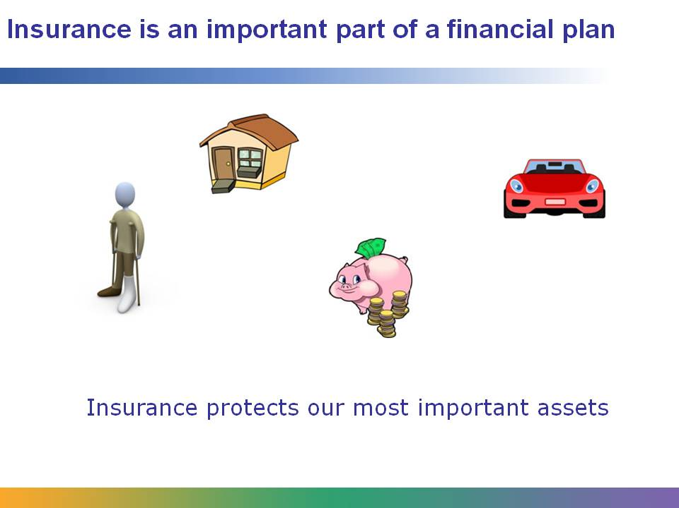  No matter how financially independent a person is, she is always at risk for an unexpected disaster. Imagine having paid off the mortgage on your home, which is now worth $300,000. Without insurance, a fire could destroy your home in just a few hours, destroying all of the equity you’ve put into the home. With property insurance, just one of the many types of insurance available, you are protected; the insurance company would pay you money to rebuild your home or buy another one. | Presentation notes
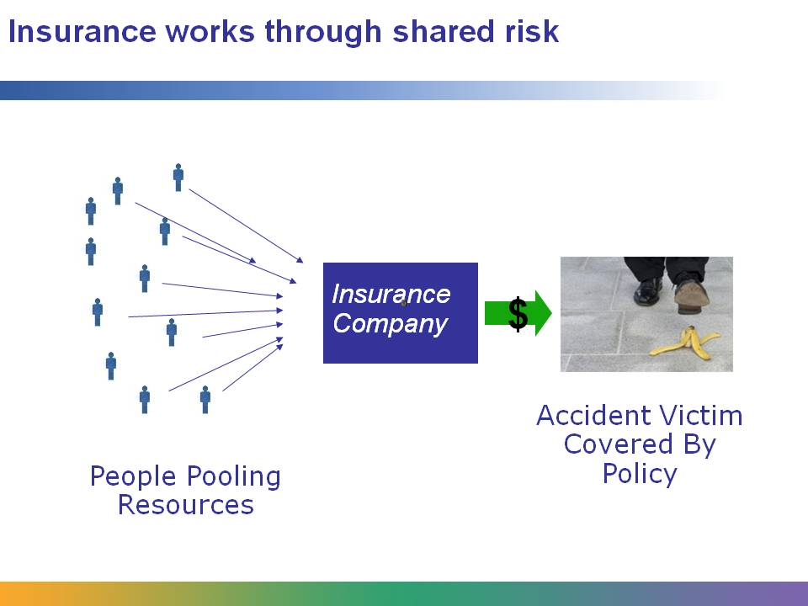  How does insurance work? The basic underlying structure of all insurance is the concept of shared risk. By paying the insurance company a “premium” for coverage, a great number of people pool together money.  If anyone in the pool suffers an event covered by his insurance policy, such as an accident, a fire, or an illness, the insurance company covers some or all of the cost, based on the terms of the insurance policy. Sometimes, in exchange for lower premiums, an insurer and customer agree that the customer will pay a certain amount of the cost of the insured event. This agreed-upon amount is called the “deductible.”  Insurance companies don’t just save the money in the bank. They invest the pooled money, generating interest and gains, which enables them to charge less for coverage. | Presentation notes
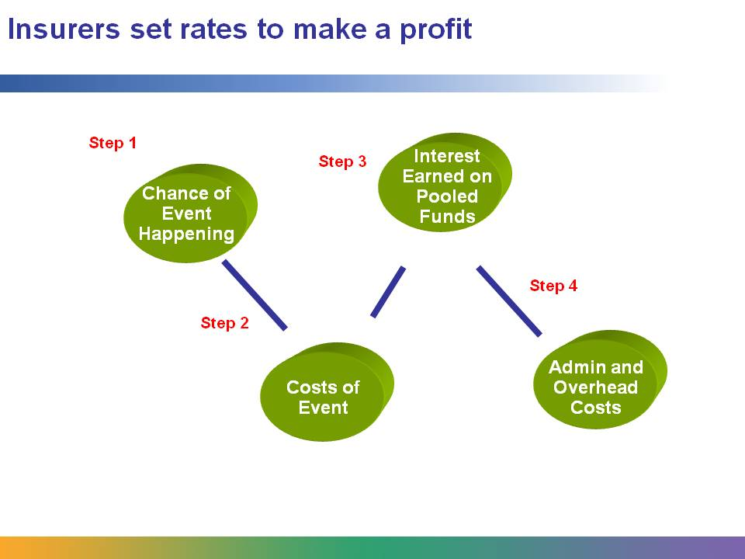  How do insurers figure out how much to charge? They follow several basic steps in setting their premiums:  - First they carefully study the chances of insured invents happening. For example, insurance companies can easily find out the number of homes that have burned down over the last 20 years in a particular city.  - Then they calculate the likely costs of such an event happening. With these two factors in hand, they can very accurately estimate the total dollar amount of payments they will have to make in a given year for a particular type of risk.  - They estimate how much they will make in interest on their investment of the pooled money.  - They add their overhead and administrative costs.  With these four factors in mind, insurance companies set premiums that will allow them not only to cover insurance claims, but also to pay for their operating costs and make a profit. | Presentation notes
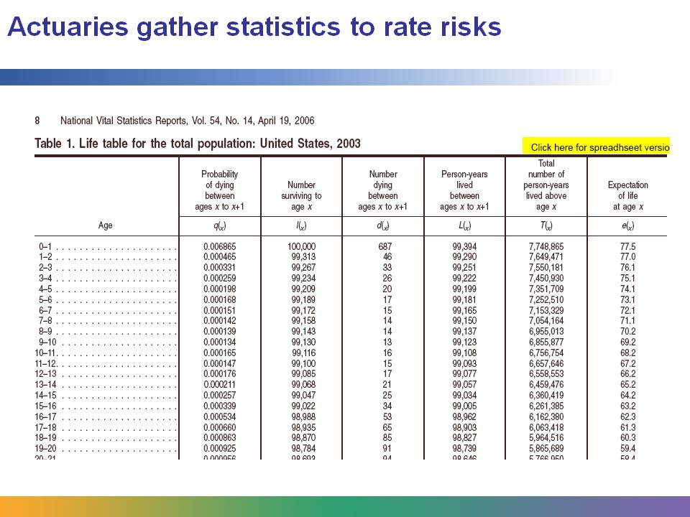  How do insurance companies know what premiums to charge in order to make sure they don’t lose money?  They carefully study statistics on the likelihood of insured events happening for different groups of people.  This is a sample of an actuarial table, listing life expectancies at different ages. These tables are created by actuaries, professionals who know how to analyze risks and costs. By gathering lots of data, insurance companies can predict with amazing accuracy the number and cost of all kinds of unfortunate events, from deaths to births to accidents to house fires.  While they can’t predict any individual’s fortune, by studying the likelihood of events occurring, insurance companies are able to set insurance premiums that allow them to cover all policies and to make a profit. | Presentation notes
  Here is a detailed view of an actuarial table.  Using this table, can you figure out the chances of a 17-year-old dying? Out of every 100,000 people, how many live to be 5? How many live to be 20? Is it more likely for a 1-year-old to die or a 16-year-old? | Presentation notes
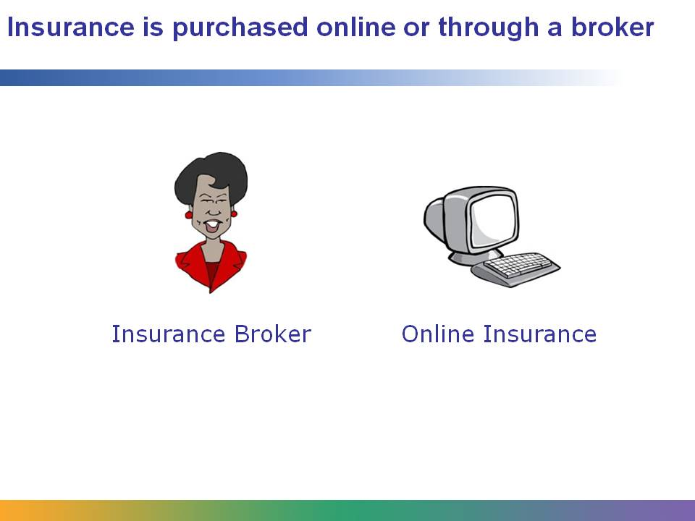  Where does one purchase insurance? The traditional way has been to contact a local insurance broker. You can find insurance brokers in the phone book or on the Internet. With today’s technology, you can also find insurance companies that will provide policies right on the Internet.  For some types of insurance, especially health and life insurance, a representative from the insurance company will likely want to find out more about you before they decide whether to provide insurance, and if so, what the premiums will be.  As in any other business, there can be scams and less-than-honest insurance brokers. It pays to research options and read the fine print to make sure an insurance plan meets your needs. One place to find information is on insurance referral sites. | Presentation notes
Teacher Resource 10.2
Assessment Criteria: Report on Types of Insurance

Student Name:______________________________________________________________
Date:_______________________________________________________________________
Using the following criteria, assess whether the student met each one.
 |  | Met | Partially Met | Didn’t Meet
Correctly identifies the main risks covered by this type of insurance. |  | □ | □ | □
Describes at least two examples of the use of this insurance. |  | □ | □ | □
Correctly identifies which age groups the insurance type is appropriate for and explains the answer. |  | □ | □ | □
Presents ideas in a clear and informative way. |  | □ | □ | □
The completed assignment is neat and legible and uses proper spelling, grammar, and punctuation. |  | □ | □ | □

Additional Comments:
_____________________________________________________________________________
_____________________________________________________________________________
_____________________________________________________________________________
_____________________________________________________________________________
Teacher Resource 10.3
Key Vocabulary: Insurance and Financial Planning
These are terms to be introduced or reinforced in this lesson.
Term | Definition
actuarial table | A table that shows the probability that a person will die before his next birthday. Actuarial tables are used to calculate insurance rates.
actuary | A mathematician who calculates the likelihood of events and prices insurance based on that likelihood.
deductible | The portion of an insurance claim that is not covered by an insurer. For example, on a $1,000 claim with a $200 deductible, the insurer would pay $800 and the claimant would pay $200.
insurance agent | An employee who sells insurance from one insurance company.
insurance broker | An independent insurance agent who sells insurance policies from more than one insurance company.
liability | A type of insurance that protects you from lawsuits, usually against your customers or people using property that you own.
premium | The cost of an insurance policy.

